

Acadmya

Website



EELU

The Egyptian-learning University

**Under Supervision of:**

# Professor: Mahmoud Mohamed Hussien

# Teaching Assistant: Mohamed Fekry

**"****Academy"**

**Our Team:**

|  |  |  |  |  |  |  |  |  |  |  |  |  |  |  |  |  |
| --- | --- | --- | --- | --- | --- | --- | --- | --- | --- | --- | --- | --- | --- | --- | --- | --- |
| |  |  | | --- | --- | | Name | ID | | Abdallah Ahmed Safi | 1901351 | | Mohamed Alaa Gaber | 2000118 | | Sara Mohamed Hamed | 2001651 | | Aliaa Mohamed Ahmed | 2001791 | | Reem Ali Mohamed | 2001450 | | Sanabel Mostafa | 2001839 | | Reem Mohamed Elhady | 2001841 | |

Contents

ACKNOWLEDGEMENTA …………………………………………………………………4

Abstract………………………………………………………………………………...…….5

**Chapter 1: Introduction**………………………………………….…….........…….... 6

1.1Document Purpose ………………………………………………………….………….7

1.2 Problem Statement……………………………………………………………...……...8

1.3 Project Scope…………………………………………………………………....……. 9

**Chapter2 Planning and Analysis**…………………………………….………...….10

2.1Product Perspective………………………………………………….…………………11

2.2Project Planning ……………………………………………………………….……….11

2.2.1Feasibility Study ………………………………………………………….………....14

2.2.1.1Technical Feasibility……………………………………………………………….14

2.2.1.2Economical Feasibility…………………………………………………………….15

2.2.1.3Organizational Feasibility…………………………………………………………16

2.2.1.4Operational Feasibility…………………………………………………………….16

2.3Analysis and limitations……………………………………………………………….17

2.3.1 Why we use our new system……………………………………………………….17

2.3.2Gap Analysis………………………………………………………………………….18

2.4User Characteristics…………………………………………………………………….18

2.5Operating Environment……………………………………………………...................19

2.6User Documentation………………………………………………………....................19

2.6.1Study of current system……………………………………………………………….19

2.6.2Functional components of project…………………………………………………….19

2.6.3 Requirement………………………………………………………………………….19

2.7Risks and Risk Management……………………………………………………………20

**Chapter 3 Analysis** ……………………………………………………………......….21

3.1 Functional Requirement… …………………………… …………….………………….22

1. 2 Non-Functional Requirement……………………….……………….…………....……22

**Chapter 4 Software Design**…………………………………………………………23

4.1 Use Case Diagrams………………………………………………………….……. ….. 24

4.2 ERD……….………………………………………………………………………………28

4.3 Conceptual Class Diagrams……...…………………………………………………….29

**Chapter 5 Implementation & Layout**………………………………………...……30

5.1 Registration and Login page………………………………………………………...…31

5.2Home Page …………………………...…………………………………………............38

**Chapter 6 Database……………………**…...………...………………………………46

6**.**1Database schemas and tables………………………………….............……47

**future work** …………….………………………………………………….……….….50

**Reference and Tools**……………….………….……………. .......................….…….51

## ACKNOWLEDGEMENTA

In the beginning, all praise and thanks be to God for the success and care that He granted us and helped us to complete our project.

Thank you to the Egyptian University for E-Learning and especially the Qena Center for helping us reach this level of awareness.

we extend our sincere thanks and appreciation to our supervisor,

**Prof. Mahmoud Mohamed Hussien** for his continuous motivation and support during our work on implementing this project, we appreciate his kind guidance and encouragement to us from the beginning of this idea to its end.

We are especially indebted to express our heartfelt thanks to

**Eng. Mohamed** **Fekry** for the guidance, constant supervision, patience, friendship and great sense of humor for all his efforts with us. Finally, we would like to express our gratitude to everyone who helped us during the graduation project.

**Abstract**

Academy is a versatile educational platform designed to offer specialized courses in web development for students aspiring to become professionals in the web domain. The platform consolidates all essential web tracks—Front end and Back-End development—into a single, comprehensive learning environment. It features both paid and free courses, with free access provided to EELU students. Upon graduating from Academy, students receive a degree in their chosen web track, eliminating the need to seek additional information elsewhere.

The primary functionality of Academy focuses on robust data storage for courses and facilitating seamless exchange of information between instructors and students. The website includes an advanced search system to help users find courses with specific deals and advantages at any given time via the Internet. This system ensures that students can easily navigate through many available courses and select the ones that best fit their learning needs.

Our platform is designed to cater to the growing demand for web development skills, ensuring that students have access to the most up-to-date resources and tools. We anticipate a 90% usage rate of our system, driven by significant technological advancements and the incorporation of user-friendly features for in-depth analysis. Academy’s user interface is crafted to provide an intuitive and engaging learning experience, encouraging continuous improvement and knowledge acquisition.

Academy provides a unique identifier for each student and automatically stores detailed information about both students and instructors. Users can search for available courses and instructor details with ease. The platform supports a dynamic and interactive learning environment, where students can engage with instructors, participate in discussions, and access supplementary materials.

The site management system, accessible with a username and password, is designed for administrators. This system allows administrators to manage course content, monitor user activity, and ensure the smooth operation of the platform. All users can access and interact with the platform, benefiting from its comprehensive features and resources.

Additionally, all critical issues such as security, error handling, and exception management will be thoroughly addressed in the implementation of the proposed system. We are committed to providing a secure and reliable platform that protects user data and ensures a safe learning environment.

Academy is poised to become a leading educational platform, empowering students to achieve their career goals in web development. By offering a wide range of courses, expert instructors, and a supportive learning community, Academy strives to make high-quality education accessible to all.

**Chapter 1**

**Introduction**

**1.1 Document Purpose**

Why Choose Academy?

Unparalleled Comprehensiveness: academy offers a holistic approach to web development education, covering everything from foundational concepts to advanced techniques. Our carefully curated curriculum ensures that you gain expertise across diverse web tracks, providing you with a comprehensive skill set highly valued in the industry.

Expert-Crafted Curriculum: Learn from seasoned industry professionals who have distilled their years of experience into engaging, effective modules. Academy’s instructors are dedicated to empowering you with the knowledge and skills needed to thrive in the competitive world of web development.

Sharpen Your Skills: At Academy, theory meets practice through interactive exercises, real-world projects, and personalized feedback. By immersing yourself in hands-on learning experiences, you'll not only deepen your understanding but also build a robust portfolio showcasing your proficiency to prospective employers.

Graduate with Confidence: Upon successful completion of our program, you'll earn a recognized degree in web development, validating your expertise and opening doors to exciting career opportunities. Whether you aspire to work as a front-end developer, back-end engineer, or full-stack developer, Academy equips you with the credentials to thrive in any role.

Data-Driven Learning: Our cutting-edge platform leverages data analytics to personalize your learning journey, ensuring that you receive tailored support and guidance every step of the way. By seamlessly storing and sharing information, the Academy fosters communication and collaboration between instructors and students, facilitating a dynamic and enriching learning environment.

But academy is more than just a course – it's a vibrant community of like-minded individuals passionate about web development. Connect with fellow aspiring developers, share your journey, and tap into the collective knowledge and support of our diverse network

**1.2 Problem Statement**

In the rapidly evolving landscape of technology, there exists a significant gap between the demand for skilled web developers and the availability of qualified professionals.

Despite the abundance of online resources and educational platforms, aspiring developers often struggle with fragmented learning experiences, lack of comprehensive curriculum, and limited opportunities for practical application and feedback.

This gap in the market presents a pressing problem for both individuals seeking to break into the field of web development and organizations in need of professional developers to drive their digital initiatives forward. Traditional educational models and fragmented learning resources fail to adequately address the multifaceted challenges of mastering web development, resulting in a shortage of qualified talent and hindering technological innovation and progress.

Moreover, the current state of online education lacks a cohesive, community-driven approach that fosters collaboration, engagement, and continuous learning among aspiring developers.

While existing platforms offer individual courses and resources, they often fall short in providing a unified, immersive learning experience that equips learners with the comprehensive skill set and practical expertise demanded by today's competitive job market.

Therefore, the problem at hand revolves around the need for a transformative solution that addresses the following key

challenges:

Fragmented Learning: Learners struggle to navigate multiple platforms and resources, leading to disjointed learning experiences and gaps in knowledge.

Lack of Comprehensive

Curriculum:

Existing educational offerings fail to provide a comprehensive, cohesive curriculum that covers all essential aspects of web development, from foundational concepts to advanced techniques.

Limited Opportunities for Practical Application: Learners lack access to hands-on projects, real-world scenarios, and personalized feedback, hindering their ability to apply theoretical knowledge and develop practical skills.

Absence of Community and Collaboration:

The current educational landscape lacks a vibrant community-driven environment that fosters collaboration, networking, and peer support among aspiring developers.

Addressing these challenges requires the development of a groundbreaking educational platform that centralizes all essential web development tracks, offers expert-crafted curriculum, provides ample opportunities for practical application and feedback, and cultivates a vibrant community of learners and instructors dedicated to mutual growth and success.

By tackling these underlying issues, the proposed solution aims to empower aspiring developers with the comprehensive skills, practical experience, and supportive community needed to succeed in the competitive field of web

development, ultimately bridging the gap between talent demand and supply and driving innovation in the digital realm

**1.3 Project Scope**

We will identify the tasks that consist of the project and do it with the language or the way that make it such as: the interface of the web site need to front end (Html, CSS, bootstrap, JavaScript, jQuery), back-end such as (PHP, Database (MySQL)).

**Chapter 2**

**Planning and analysis**

* 1. **Product Perspective**

Instructors add a course that describe what is Tech then review Student submit and student enroll courses by get offers from trusted instructors and view profiles then get it done by choose the right instructor for the course that choice and get it done.

* 1. **Project Planning**

|  |
| --- |
| **System Request-(Academy)** |
| **Project**  **Sponsor:**  Dr /Mahmoud, |
| **Business Need:**  The project aims to serve students and instructors in our country, which saves effort and time for students in studying and obtaining the appropriate scientific competence and keeping pace with the tremendous technological development in our modern era in accordance with the rules of developing E-Learning and the instructor works to increase personal income and save wasted time in searching for a place to describe the courses and know the details and requirements of the course to be explained and communicate with students. |
| **Business Requirements:**  By using this system you will:   1. searching for courses and know their details. 2. Propose in the courses. 3. view details about student that Enrolled in his course. 4. Contact Between instructor and student that enrolled in the course to more descriptions. 5. Know the rate of the instructor 6. Know the latest news about available courses 7. Quizzing the student after finished his course |
| **Business Value:** We accept that system which we built can attract students, instructors and companies that make online advertisements  5%$ Student.  25%$ advs.  10%$ instructor. |
| **Special issues or constraints:**  - The deadline for completion of the project after 5 months from now.   - Team members have a minor difficulty in the development stage.  - User familiarity with English GUI provide Arabic GUI The system should be delivered within Five months. |

**Work Plan: -**

|  |  |  |  |  |
| --- | --- | --- | --- | --- |
| **Task ID** | **Task Name** | **Assigned to** | **Estimated Time** | **Actual Time** |
| **1** | Intro & Project scope | Reem Ali | 10 Days | 10 Days |
| **2** | Background & Related work | Reem Mohamed | 3 Days | 2 Days |
| **3** | System Request | Abdullah | 5 Days | 4 Days |
| **4** | Feasibility study | Sara | 5 Days | 5 Days |
| **5** | Risk management | Sanabel | 3 Days | 2 Days |
| **6** | Work plan & Gantt chart | Sara | 4 Days | 2 Days |
| **7** | Database tables | Adullah & Mohamed | 4 Days | 4 Days |
| **8** | System interface | All Team | 10 Days | 10 Days |
| **9** | Actor & goals | Sanabel | 2 Days | 2 Days |
| **10** | Use Cases | All Team | 8 Days | 8 Days |
| **11** | Use case Diagram | Sanabel | 2 Days | 2 Days |
| **12** | Conceptual classes | Reem  Mohamed | 2 Days | 2 Days |
| **13** | Domain model | Mohammed | 3 Days | 2 Days |
| **14** | System sequence diagram | Abdullah | 3 Days | 2 Days |
| **15** | Sequence diagram | Reem Ali | 3 Days | 2 Days |
| **17** | Design class diagram | Aliaa | 4 Days | 3 Days |
| **18** | Implementation | All Team | 8 Weeks | 8 Weeks |

Table 1.1 work plan

* + 1. **Feasibility Study**

The main purpose of feasibility analysis is to check the economic viability of the  
proposed system. The result of the feasibility study will indicate whether to proceed  
with the proposed system or not. If the results of the feasibility study are positive,  
then we can proceed to develop a system otherwise project should not be pursued

**2.2.1.1 Technical Feasibility**This system will be developed using (web develop language and MySQL for database) . As we require some time to learn all.  
these technologies, all these technologies are easy to learn and can develop system  
very rapidly. After developing and deploying the system, any user can view this site  
on the Internet.

1. **Familiarity with applications (Is High)**

* Our familiarity is high as Student, instructor have enough experience about how to deal with the website and applicant.
* Our Teamwork has a lot of experience in the operation of

the system (Application area).

* We have high familiarity with other sites that looks like us

system like (Udemy– Coursera).

**2-Familiarity with technology (is medium)**

* The system will be a web application
* Our familiarity is high as, we have good experience at: html, CSS, java script, jQuery, PHP and SQL server.

**3-The project size risk: (is medium)**

* The project team will include 7 members.
* We can finish this project at most 5 months.

We think that we have the skills and ability for coding, design and implementing the project.

**2.2.1.2 Economical Feasibility**Proposed System requires development tools and software such as Bracket and Visual Studio. Which are free of cost and available on internet. For developing proposed system, we  
need various resources such as computers systems, internet connection for e-help  
recommended disk space, and memory speed as mentioned in technical requirement. By  
looking at all these expenses and comparing with proposed system, we have many  
benefits from proposed system such are:   
**1-**As existing system is manual, where data may not accurate, up to date, and  
available on time. But proposed system will be computerized, so we can  
overcome all limitations of existing system. Also, with this new system  
insertion, deletion, and modification of various data will be easier to  
handle.

**2-**This system will reduce the paperwork. And quality of data will be  
improved.  
So keeping all above-mentioned benefits and comparing with various expenditures of  
resources, we conclude that proposed system is economical feasible.

**3-**This economic feasibility explains all related costs and benefits in Academy system.

Development costs (one time cost)

Programmers money (30000 pounds) -Server costs (20000 pounds)

**\*Benefits:**

Our project is a service to student, so the economic feasibility benefits are indirect, so we suggest that:

1-We can gain money from advertisement.

2-We can gain money from ratio between student and instructor.

**2.2.1.3 Organizational feasibility**

1) Project sponsor

* Students need this system to facilitate all process to search and find Courses.

1. System users

* Our users need fast and good system to deal with it.

### **3**) Project management

* Student and instructors should have enough knowledge about the system

And how to learn and tech with technology.

**2.2.1.4 Operational feasibility**Users of the system will the registered user of the website.

To put a course user should have only basic knowledge of computer and Internet  
, which is not a big issue.  
Basic training is required for other users to handle and manage the information.

* 1. **Analysis and** **Limitations**

**2.3.1Why we use our new system (Academy)?**

**1-** Website will provide the separate user accounts, which are used  
to upload Courses, update profile and enrolled for multiple courses.  
**2-** Provide easy and quick search of Course from this application.  
**3-** This application provide user on criteria that is alone by specific user  
account.  
**4-** User can update profile and courses for different types of course category

**5**-More interactive

**6**-. Alot of free Courses for EELU-Student

**7**-Enhance the quality of learning and teaching

**8**-Have a road map for learning and coursing track from A-Z.

**2.3.2 GAP Analysis of New System**

**2.4Users Characteristics**

There are three types of users that interact with the system:

**1-Instructor: -** Enter to system and create an account as instructor and can add picture and profile to him with method way to take money. Add course to system and can add any student from who sent enroll to his course can search for a specific student can add assignment for student that enroll with his course and make a certification for student that finished course and success in courses.

**2-Student: -** Enter to system an create an account as student and choose category that can search a course for it, write description for him and choose picture, university and location, can add finished courses to profile, and can send request to enroll course that choice in different category.

**3-Customer Support: -** A professional person who add test question to system with time for every test and can solve complaint from instructor or student.

**2.5 Operating Environment**

The system can be defined as a website is opened from any browser and internet .

**2.6 User** **Documentation**

**2.6.1 Study of current System:**This application having database which is a repository of an organization’s  
electronically stored data. The databases are designed to facilitate analysis.  
The classic Functionality of this Application focuses on data storage. However,  
the means to retrieve and analyze data, to extract, transform and load data, and to  
manage the data dictionary.  
**2.6.2 Functional Components of the project:**• To facilitate easy maintenance of records of various Recruiters   
(Companies), courses and Student.  
• To check for details prospective Course enrollment through quick search  
provided in the portal.  
• To check for matching course with students.  
• Quick access of all record.  
• To match the suitable candidates to appropriate course.  
• Prevent and reduce human error.  
• Reduce manual work.

**2.6.3 Requirement of new system**The new system that was to be built in the organization need to have some creative  
concept that can help the user in the real manner and the next important thing is that it  
should give the cost effective solution to the user. Due to the collaborative nature of  
the application the user can really be an important part of it rather than just using it  
blindly. As the prior applications were not providing the user portability, the new application should be created for manage courses and students (E-Learning) so  
  
**2.7Risks and Risk Management**

In this section we will talk about the risks that our team can face while developing the project

* collecting wrong information about courses (category, instructor info, student info) for database.
* High cost of hardware.
* The time which we can’t finish this high project.
* Difficulty with understanding the existing system paper.
* Our technical skill needs to learn more and more.
* Save and retrieve various data is difficult will make more time and effort.

## *Solutions*

* We will try to work with the minimum hardware which

serve the whole process but minimize the cost in the beginning

* Time is Essential Factor so we will accelerate the time of deliver the project by Using Accelerator method such increasing the number of developers considering minimizing the Cost.
* The existing System is difficult and large so for avoiding misunderstanding the system we make a periodically Interview, Questionnaire and Search in documents, which is done before.

**Chapter 3**

**Analysis**

**3.1 Functional Requirements**

1. student shall register to take the courses in Academy.
2. student shall enroll his name and e-mail so that he can answer the quiz questions.
3. student shall finish the material course so that the quiz could be opened.
4. student shall choose from levels(easy-normal-difficult) to start taking the course.
5. student shall submit his answers in the quiz so that he can see the review of the quiz.
6. student shall pass the needed Assessments of the quiz so that he can take upcoming material course.
7. student shall enroll in the paid courses so that he can join the chat room and take the course.
8. student shall pass all the needed Assessments after every quiz to get the certification.
9. instructor shall register to upload his course and create new chat room for his student.
10. instructor shall fill the course information form to stat publishing his new course.
11. instructor shall fill the lesson information form to stat publishing his new lesson.
12. instructor shall fill his information to be shown in his profile.
13. instructor shall save his information so it can be shown in his profile.
14. instructor shall fill the room information form to stat creating his new room.
15. student shall enroll to the course so that instructor get notification about his request.
    1. **Non-Functional Requirements**
16. student shall take the three adaptable ways of the material to pass the course and get the certification.
17. student shall register to see the courses available in the academy.
18. student shall take different level of the same course if he did not pass the needed Assessments of the quiz.
19. student shall answer all the questions in the quiz so that he can see the review of the quiz.
20. instructor shall follow the tips to start his new course.

6)instructor shall fill all the information in the form to start publishing for his course.

7)instructor shall fill all the information in the form to start publishing for his lesson.

8)instructor shall choose image for his course.

9)instructor shall fill all his information to be shown in his profile.

**Chapter 4**

**Software Design**

**4.1 Use Case Diagrams**

**For Registration**

**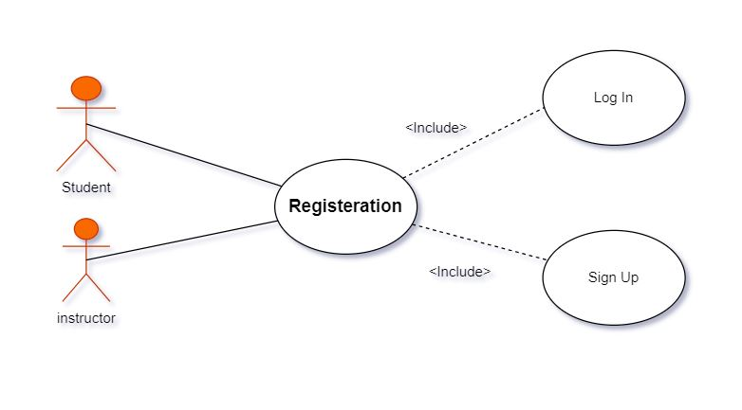**

**For Student**

**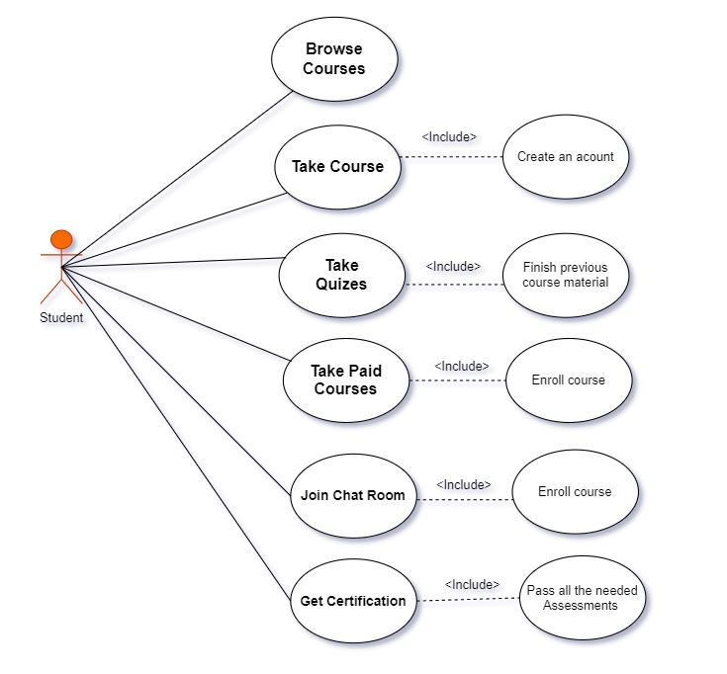**

**For Instructor**

**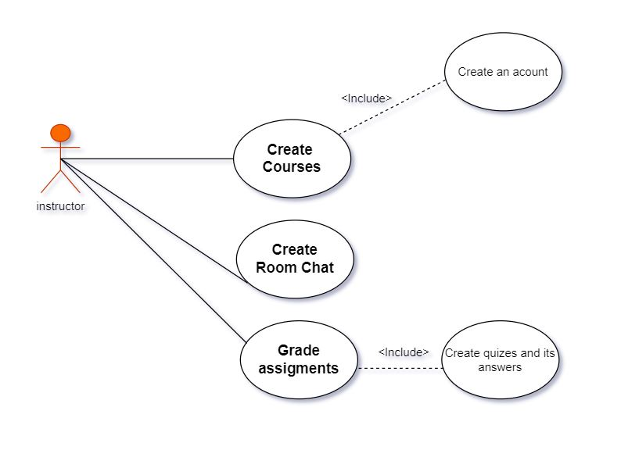**

**For Admin**

**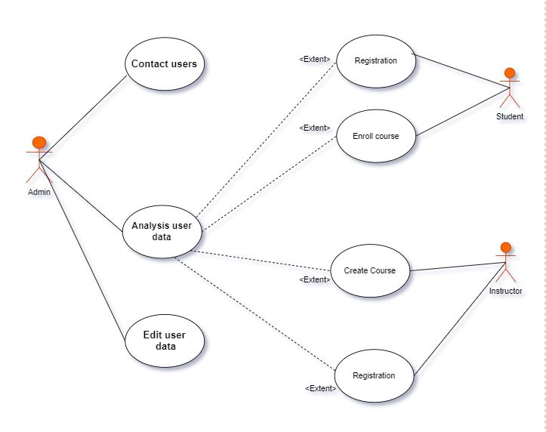**

**4.2 ERD**

**4.3 Conceptual class diagram**

**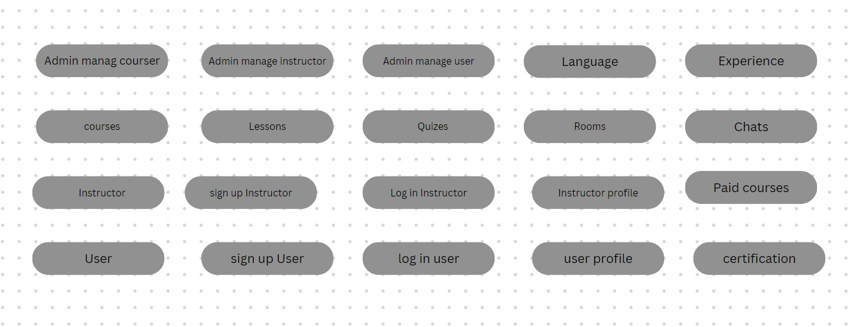**

**Chapter 5**

**IMPLEMENTATION**

**We are using:**

**1-apps for building our website xamp local server – sublime text3.**

**2-using this web technique**

**Html5 – css3 – back-end – jQuery -front -end-JavaScript – PHP -MySQL database**

## First Screen in App

**5.1 Registration and Login page**.

• **Login page**

A login page is a web page or an entry page to a website that requires user identification and authentication, regularly performed by entering a username and password combination.

Logins may provide access to an entire site or part of a website, this is the first procedure after the introduction, and he must add his email and password, if the user does not have an account, go to the RE

• **Registration Page**

A registration form is a list of fields That a user will input data into and submit to a database, he must add his Username, Email Address, Password and his Phone Number to create account.

**Registration page Containing:**

**Code Implementation**

In the Login Page we have used some Text Form Fields to control the data and handle the login process and this is an example for a Text Field, Using the Text Form Field to reset the password Using the Fire-base to Authenticate Him.

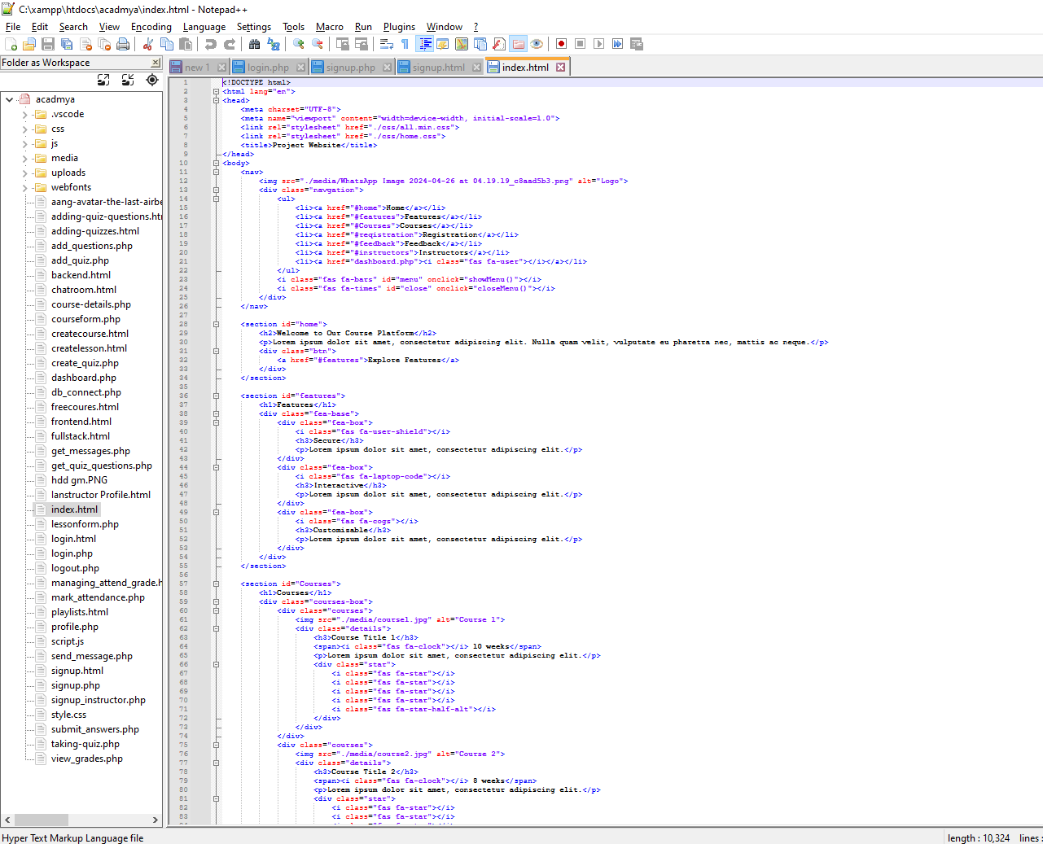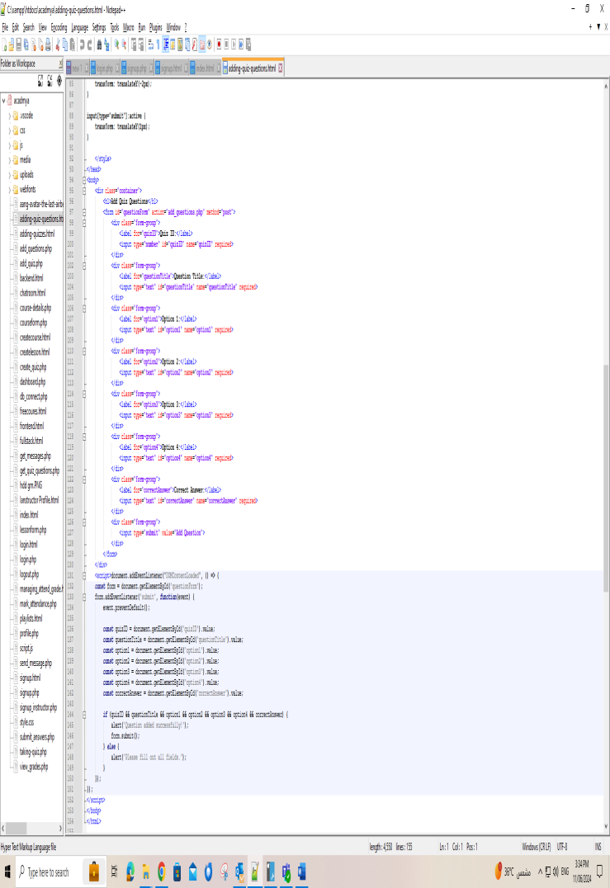

**Code Implementation:**

Here is another Example for the Registration Screen Using the Text Form Field Widget control the name and email address.

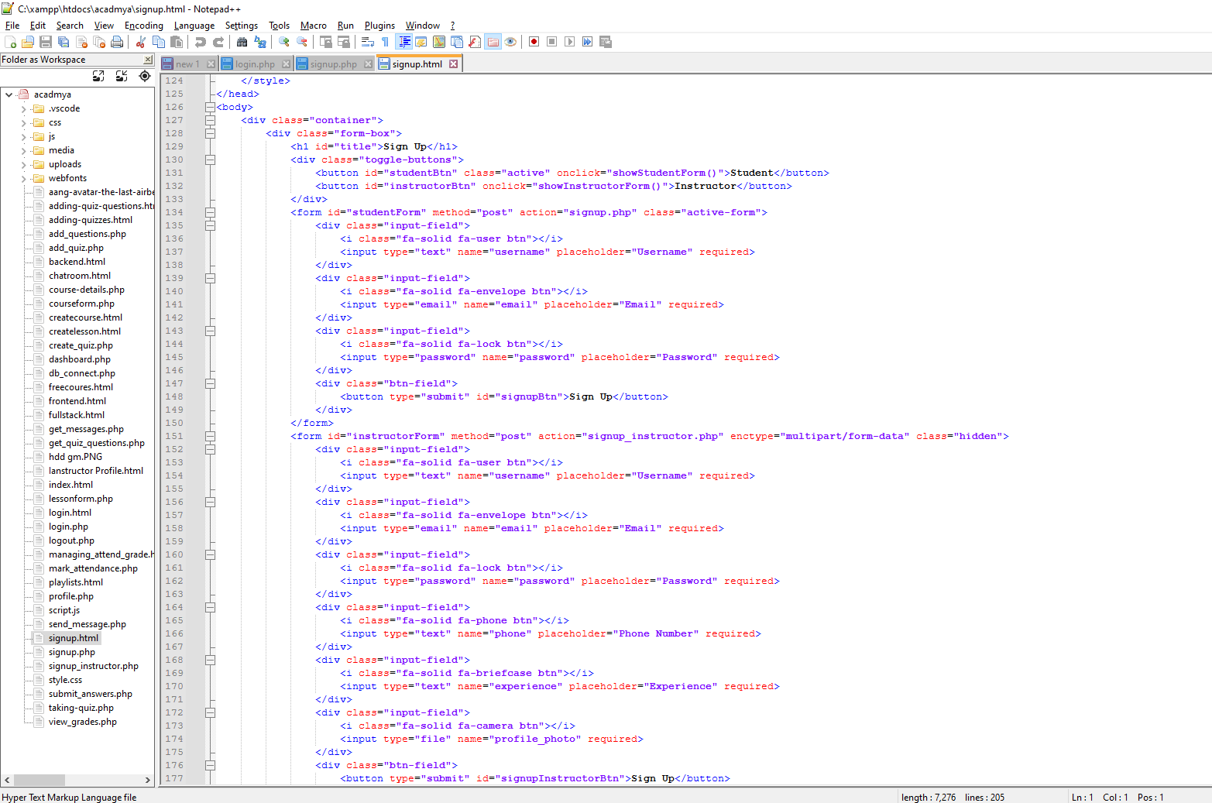

**5.2 Home Page**

* **Student**: Users can access a list of available courses and instructor, view details about their courses, quizzes, and instructors.
* **instructors**: Displays the courses available allows users to choose the courses that suits them.
* **Messages**: Supports room chat that helps student to answer their questions about courses and more.
* **settings**: It contains everything related to the application and the user

The homepage also usually provides additional options, such as viewing user reviews, contacting users service, and getting help if needed.

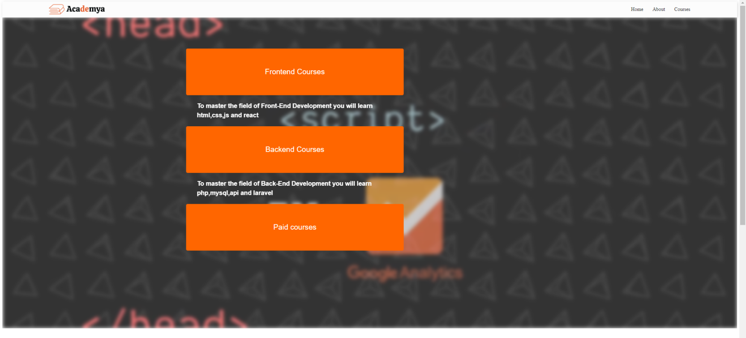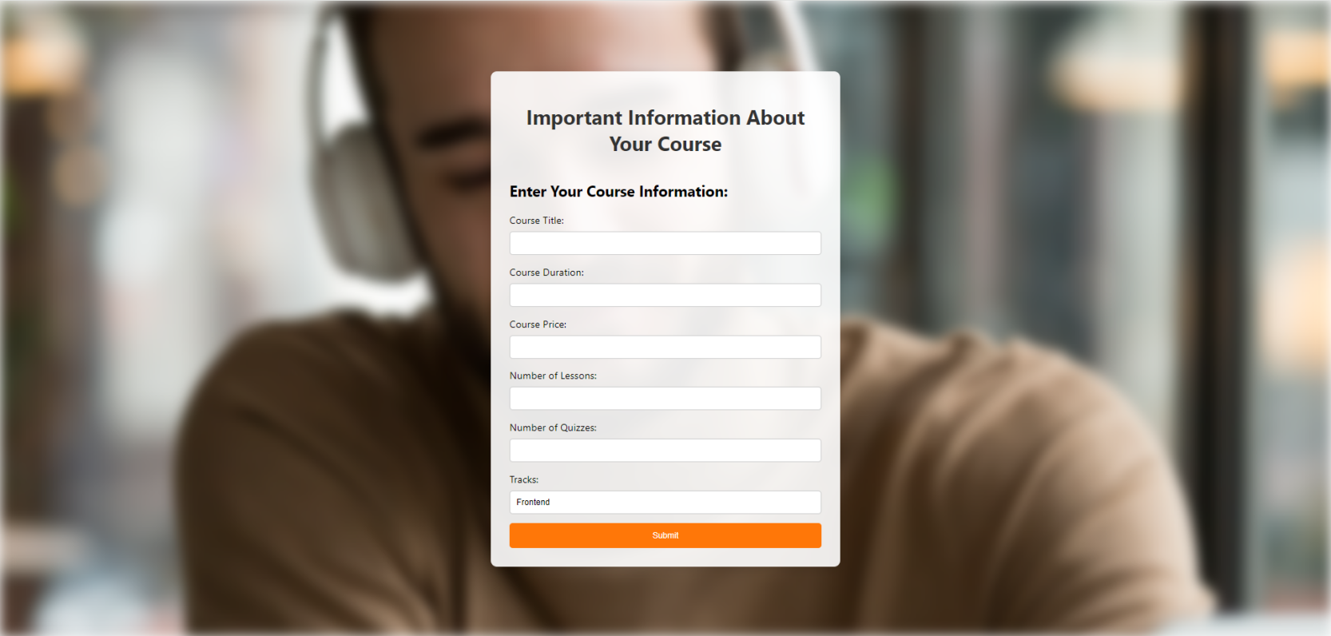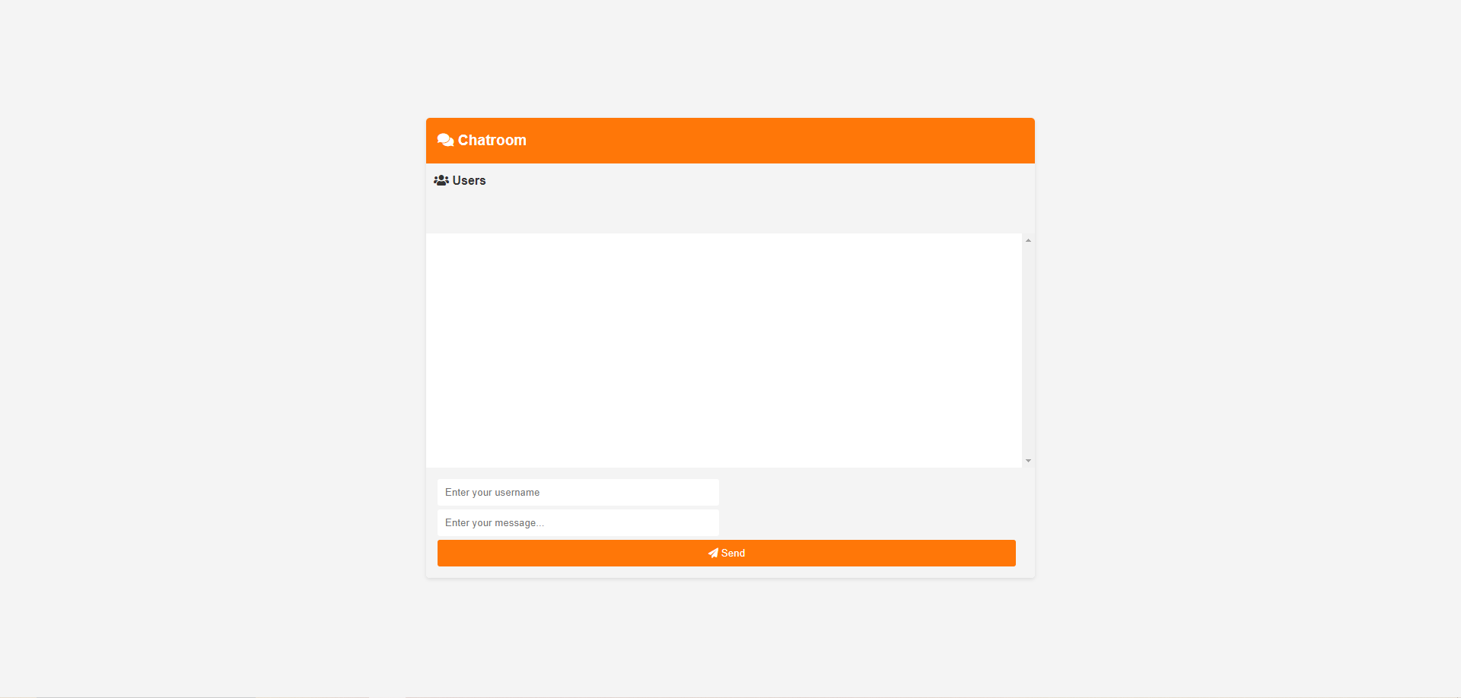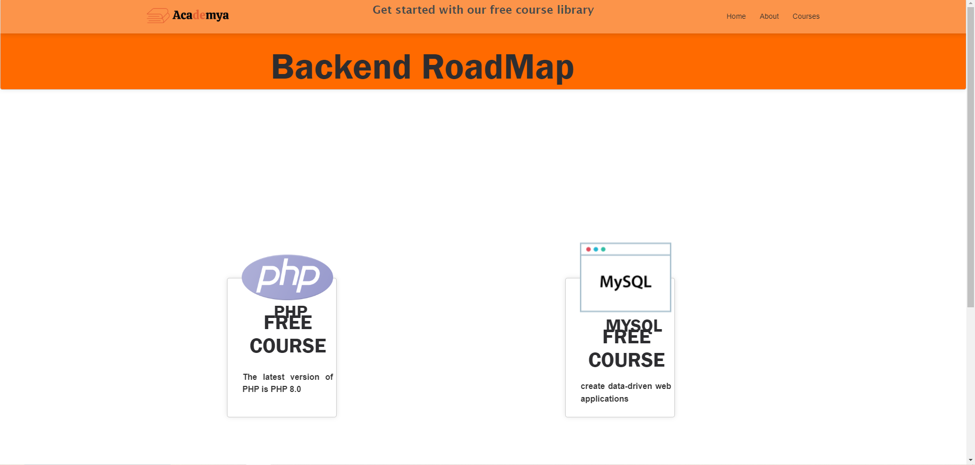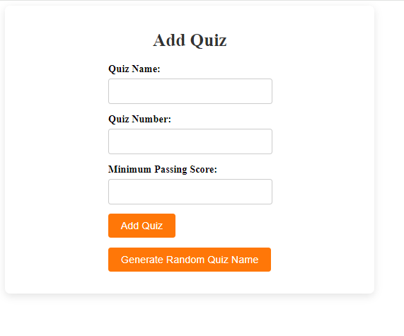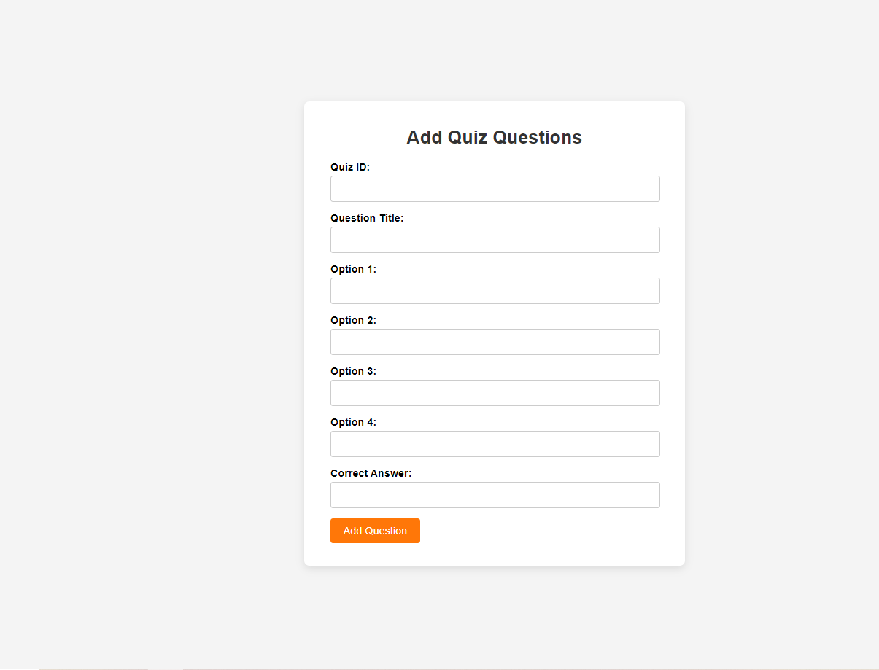

**Code Implementation:**

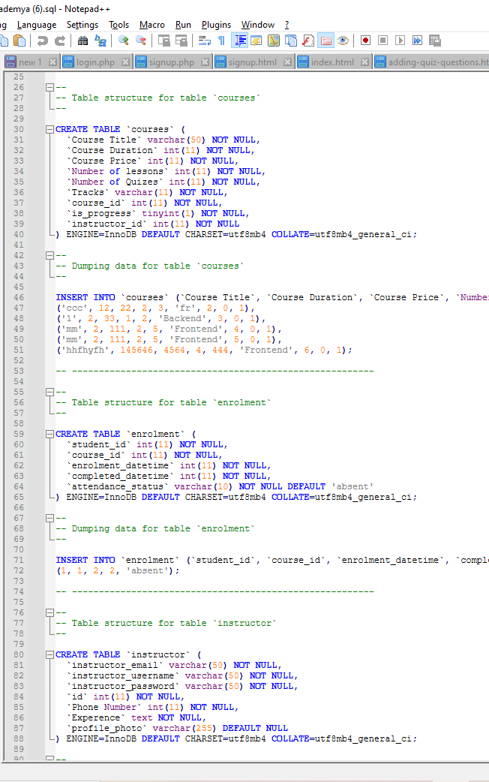

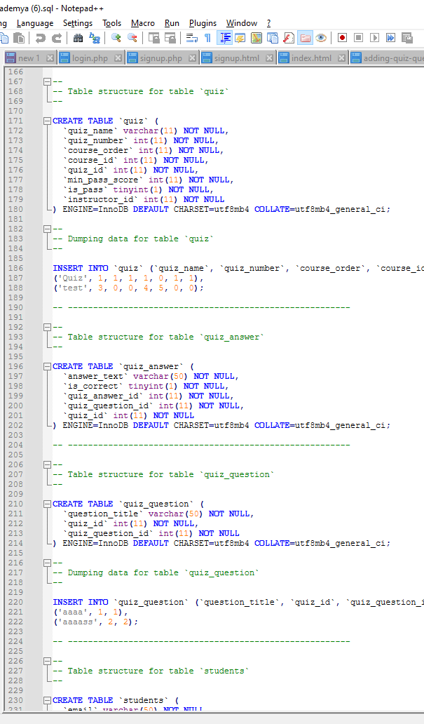

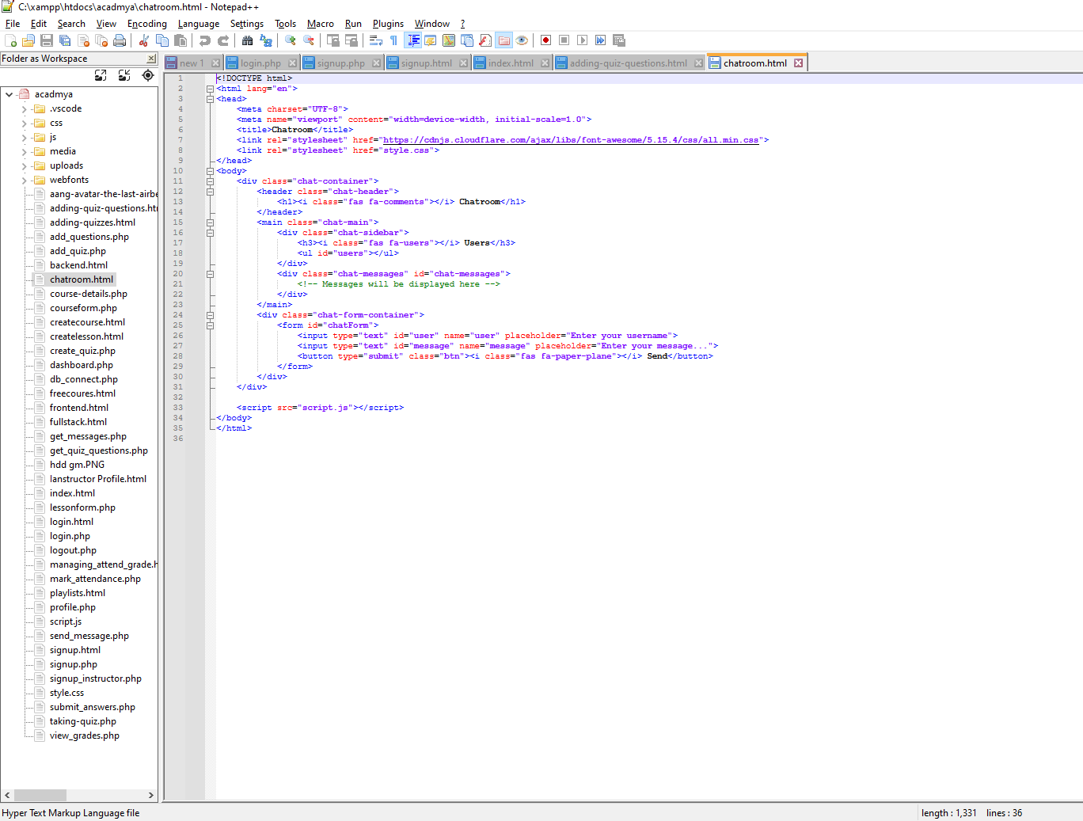

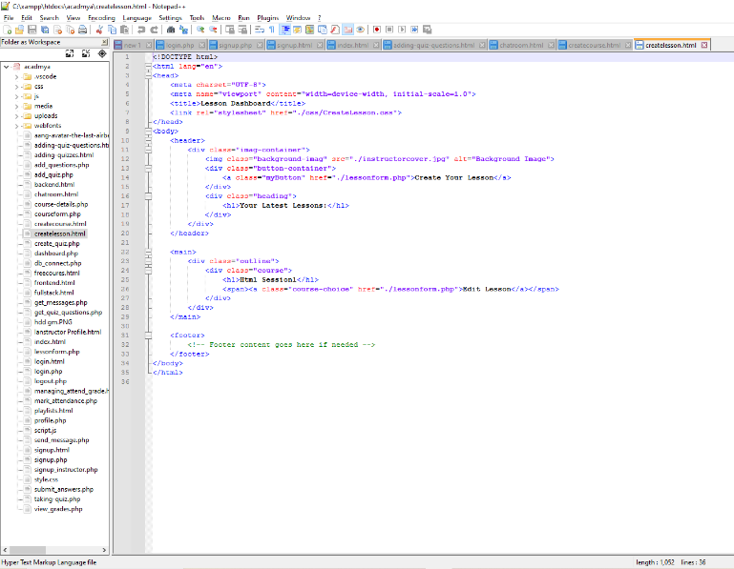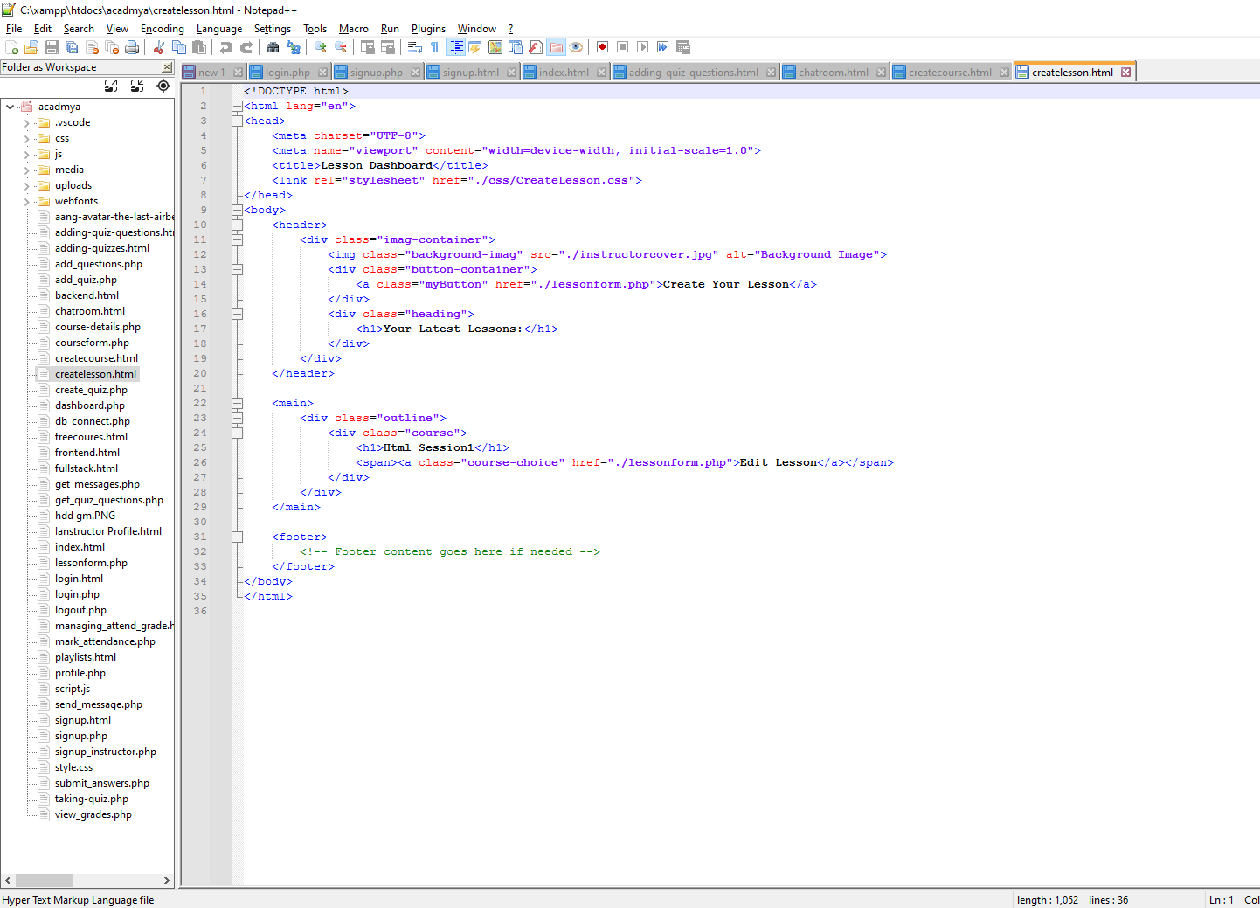

.

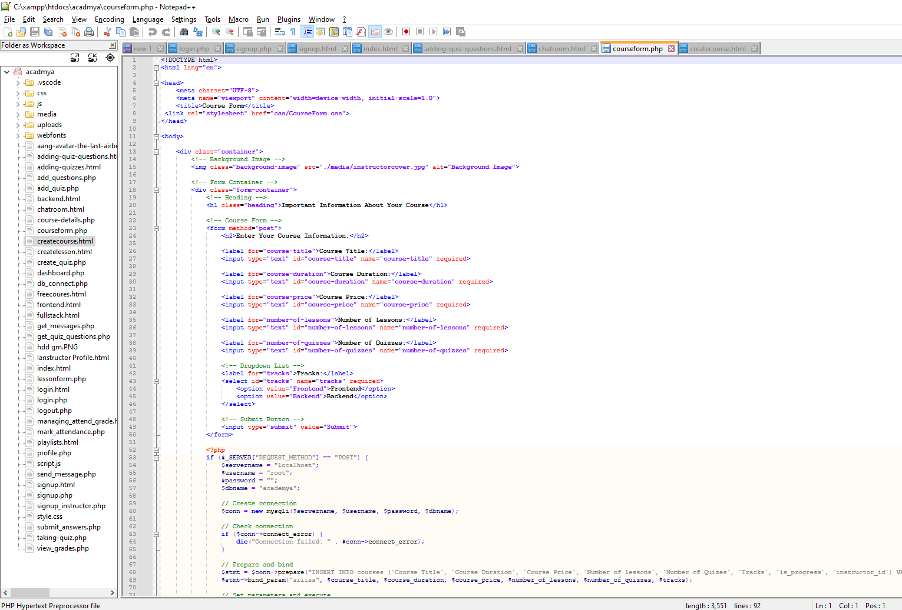

**Chapter 6**

## Database

**Database About Student and instructors:**

**Schema:**

Student Entity:

* Student \_Id (the student's unique identification number)
* Username (student's name)
* Email
* Password (student's password)

Instructors Entity:

* Instructor \_Id (the instructor's unique identification number)
* Username (instructor's name)
* Experience (experience of instructor)
* Phone number (instructor’s phone number)
* Email (instructor's email)
* Password (instructor’s password)

Courses Entity:

* Course \_Id (the Course unique identification number)
* Course tittle
* Course Duration
* Course Price
* Number Of Lesson
* Number Of Quizes
* Tracks
* Is Progress
* Instructor Id

Enrolment Entity:

* Course \_Id (the Course unique identification number)
* Student \_Id
* Enrolment\_Datetime
* Complete\_Datetime
* Attendance\_Status

Lesson Entity:

* Lesson \_Id (the Lesson unique identification number)
* Lesson tittle
* Lesson Duration
* Lesson Description
* File\_URL
* Video\_URL
* The Order Of Lesson
* Course Id

Message Entity:

* Id (the Message unique identification number)
* User
* TimeStamp
* Message

## Future Work

In the future We will create interactive challenges and projects for users. We will update the course content regularly.

We will ensure that our website is accessible to users with disabilities. We will organize live programming sessions with experienced developers.

We will add courses and educational paths that are not currently available and covered. We will be implementing a subscription model. We will consider developing a mobile application. We will collect feedback from users to improve the user experience and identify areas of improvement in the course content.

We must stay up to date with the latest developments in web technologies to keep our content fresh and relevant. In addition, interacting with your user community and responding to their needs and feedback will contribute to the long-term success of our project. We will develop a dedicated section for career resources.

**References and Tools**

1. Bracket - Text Editor. (n.d.). Bracket is a lightweight yet powerful text editor designed for web development. It offers features such as syntax highlighting, live preview, and extensions for enhanced functionality. Retrieved from [http://brackets.io/](http://brackets.io/" \t "_new)
2. Sublime Text 3. (n.d.). Sublime Text 3 is a sophisticated text editor for code, markup, and prose. It provides a sleek interface, powerful customization options, and a wide range of plugins to enhance productivity. Retrieved from [https://www.sublimetext.com/](https://www.sublimetext.com/" \t "_new)
3. Visual Studio. (n.d.). Visual Studio is an integrated development environment (IDE) from Microsoft. It offers a comprehensive suite of tools for building, debugging, and deploying applications across various platforms. Retrieved from [https://visualstudio.microsoft.com/](https://visualstudio.microsoft.com/" \t "_new)
4. MySQL Database. (n.d.). MySQL is an open-source relational database management system (RDBMS) known for its reliability, scalability, and performance. It is widely used in web development for storing and managing structured data. Retrieved from [https://www.mysql.com/](https://www.mysql.com/" \t "_new)
5. Firebase. (n.d.). Firebase is a comprehensive platform for building web and mobile applications. It offers features such as authentication, real-time database, cloud storage, and hosting, enabling developers to create powerful and engaging experiences. Retrieved from [https://firebase.google.com/](https://firebase.google.com/" \t "_new)

**THANK YOU**